**Original Image**

import cv2

import matplotlib.pyplot as plt

path = r'C:\Users\admin\Documents\3021167 Shreyas Patil\flower.jfif'

img2 = cv2.imread(path, 0)

plt.imshow(img2, cmap='gray')

plt.title("Original Image")

plt.axis('off')

plt.show()

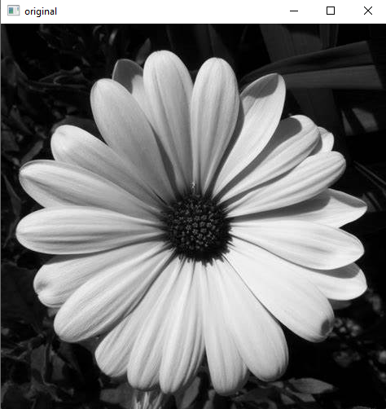

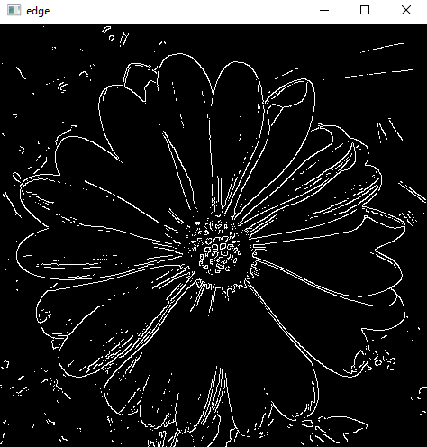**CANNY EDGE**

t_upper = 150

t_lower = 150

edge = cv2.Canny(image, t_lower, t_upper)

cv2.imshow('original', image)

cv2.imshow('edge', edge)

cv2.waitKey(0)

cv2.destroyAllWindows()

plt.subplot(1, 2, 2)

plt.imshow(edge, cmap='gray')

plt.title('Edge-detected Image')

plt.axis('off')

plt.show()

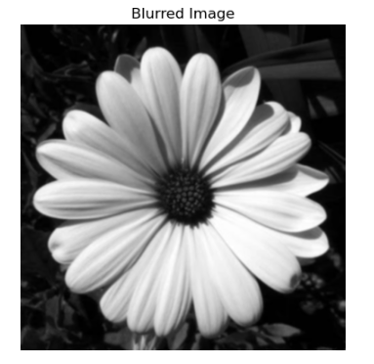**Blurred Image (gaussian blur)**

blurred_img = cv2.GaussianBlur(img2, (5, 5), 0)

plt.imshow(blurred_img, cmap='gray')

plt.title("Blurred Image")

plt.axis('off')

plt.show()

**SOBEL IMAGE**

**#blurred image defined above**

sobelx = cv2.Sobel(blurred_img, cv2.CV_64F, 1, 0, ksize=5)

sobely = cv2.Sobel(blurred_img, cv2.CV_64F, 0, 1, ksize=5)

sobelxy = cv2.Sobel(blurred_img, cv2.CV_64F, 1, 1, ksize=5)

plt.figure(figsize=(10, 5))

**# Display Sobel x image**

plt.subplot(1, 3, 1)

plt.imshow(sobelx, cmap='gray')

plt.title('Sobel X')

plt.axis('off')

**# Display Sobel y image**

plt.subplot(1, 3, 2)

plt.imshow(sobely, cmap='gray')

plt.title('Sobel Y')

plt.axis('off')

**# Display Sobel xy image**

plt.subplot(1, 3, 3)

plt.imshow(sobelxy, cmap='gray')

plt.title('Sobel XY')

plt.axis('off')

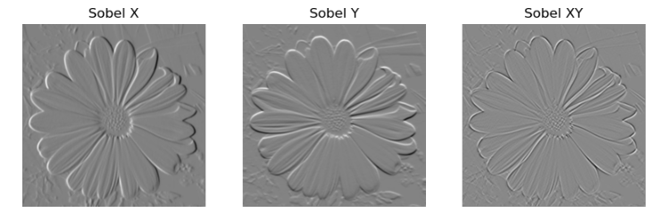plt.show()

**Changing the kernel size :**

#different kernel sizes

kernel_sizes = [3, 5, 7]

plt.figure(figsize=(15, 5))

for i, ksize in enumerate(kernel_sizes):

sobelxy = cv2.Sobel(blurred_img, cv2.CV_64F, 1, 1, ksize=ksize)

plt.subplot(1, len(kernel_sizes), i+1)

plt.imshow(sobelxy, cmap='gray')

plt.title(f'Kernel Size: {ksize}')

plt.axis('off')

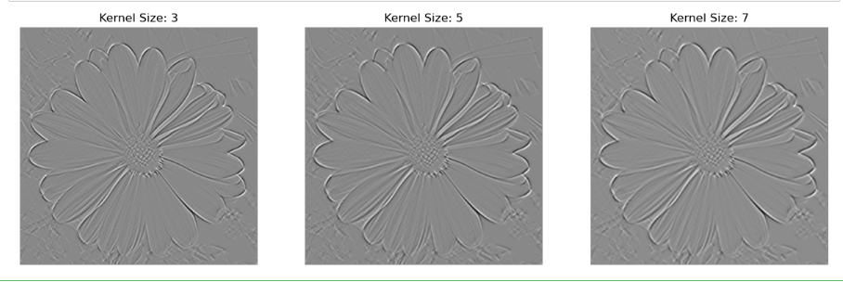plt.show()